Pricing User Manual

Step 1: Login to Admin Panel UAT: https://jio-dms-service.extensions.jmpx3.de

Step 2: Go to Data Upload. Select Template Type as ‘Pricing’.

Step 3: First, set up the Retailer Margin. This is the base to set up Distributor & Anchor Distributor pricing. For setting up the Retailer Margin, select sub type as ‘Retailer Margin Rules’.

Step 4: Download the template. Fill in the details by referring to sample data and attribute details to fill the template correctly.

Step 5: Upload and submit on Admin Panel.

Step 6: View in the logs the status of the upload. If it fails, you can download the error file to know what errored out and for which reason.

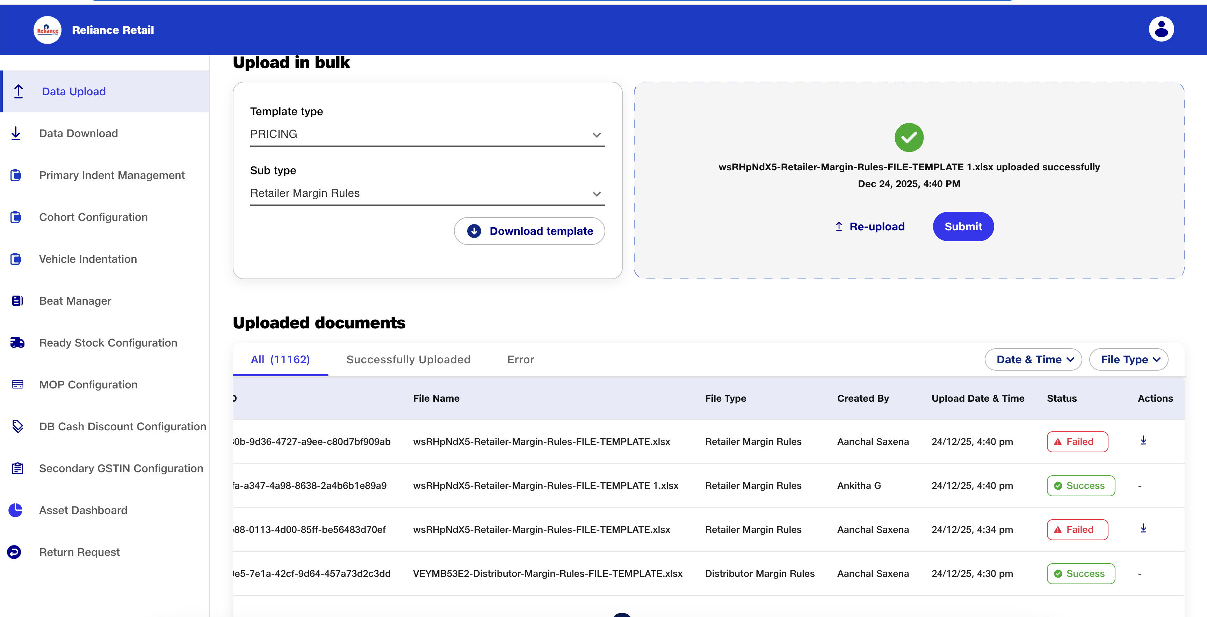

Step 7: Once the retailer margin is set, user can define distributor margin using sub type of ‘Distributor Margin Rules’ & define anchor distributor margin using sub type of ‘Anchor Distributor Margin Rules’.

Step 8: Once these are done, the retailer/distributor/wholesaler schemes can be set under sub type of ‘Retailer Scheme Rules’, ‘Distributor Scheme Rules’ and ‘Anchor Distributor Scheme Rules’

Step 9: Once the margins and/or schemes are set, the cron needs to be run for prices to reflect. This is only in UAT.
curl --location 'https://jio-dms-pricing.extensions.jmpx3.de/dms/pricing/api/v1/product/testCron/rules?tenant=RCPL'
Step 10: To set up virtual groups for Distributors, Anchor Distributors, use the sub type of ‘Virtual DB Grouping’. Once uploaded successfully, use the Virtual DB grouping ID to set the margin and/or scheme rule.

Step 11: To set up virtual article grouping, use the sub type of ‘Virtual Article Grouping’. Once file is uploaded successfully, use the Virtual article grouping ID in the margin and scheme files.

Note:
1. All pre-requisites to articles listing on PLP should be completed to ensure article is visible.

